1. Description of motion

I. 1D motion: units in kinematics, position, velocity, acceleration, graphical description;

II. description of 2D motions: vectors, meaning and their operations;

III. measurement of position, velocity and acceleration and numerical integration of the motion laws. (on the limit of the finite differences to small time steps, on the use of the finite differences)

**Position x**: location of the particle with respect to a chosen reference point

**Displacement Δx**: change of position of a particle in some time interval, as the particle moves from an initial position xi to a final position xf its displacement is given by

(Δ denote the *change* in quantity)

Δx = xf - xi

Δx is positive if xf > xi

Δx is negative if xf < xi

Displacement ≠ distance traveled

* Distance: length of a path followed by a particle, always a positive number
* Displacement if the particle ended at the same point of start (xf = xi) is 0, can be positive or negative

Vector quantity: require specification of both direction and magnitude

Scalar quantity: numerical value and no direction

**Average velocity**: particle’s displacement Δx divided by the time interval Δt during which that displacement occurs [m/s]

Vx, avr= Δx / Δt

Can be positive or negative, depending on the sign of the displacement

Speed ≠ velocity

* velocity: run distance *d* and finish at the same point, displacement is 0 (Δx=0), so the average velocity is 0. displacement/time interval
* speed: distance/time interval

**Average speed**: scalar quantity, total distance *d* traveled divided by the total time interval required to travel that distance [m/s]

V avr= *d* / Δt

## 2.2 Instantaneous Velocity and Speed

**Instantaneous velocity**: limiting value of the ratio Δx/Δt as Δt approaches zero [m/s]

The instantaneous velocity can be positive, negative or zero

**Instantaneous speed**: magnitude of its instantaneous velocity, as no direction associated with it

## 2.3 Analysis Model: Particle Under Constant Velocity

**Position as a function of time for the particle under constant velocity model**:

xf = xi + vxt

## 2.5 Acceleration

When the velocity of a particle changes with time

**Average acceleration**: change in velocity Δvx divided by the time interval Δt during which that change occurs [ m / s2 ]

ax,avr = Δvx / Δt = (vxf - vxi) / (tf - ti)

Can be positive or negative

**Instantaneous acceleration**: limit of the average acceleration as Δt approaches zero

## 2.7 Analysis Model: Particle Under Constant Acceleration

If the acceleration is constant, the average acceleration ax,avr over any time interval is numerically equal to the instantaneous acceòeration ax

**Particle under constant acceleration**:

vxf = vxi + axt (for constant ax)

Allows us to determine an object’s velocity at any time t

**Average velocity in any time interval**: because velocity at constant acceleration varies linearly in time, we can express it as the arithmetic mean of the initial velocity vxi and the final velocity vxf

(for constant ax)

**Position of an object as a function of velocity and time for the particle under constant acceleration model**: the equation provided the final position of the particle at time t in terms of the initial and final velocities

xf = xi + 1/2 (vxi + vxf) t (for constant ax)

**Position as a function of time for the particle under constant acceleration model**:

xf = xi + vxi t + 1/2 ax t2

**Velocity as a function of position for the particle under constant acceleration model**: provided the final velocity in terms of the initial velocity, the constant acceleration and the position of the particle

vxf2 = vxi2 +2ax(xf - xi )

## 

## 2.8 Freely Falling Objects

Freely falling object: any object moving freely under the influence of gravity alone, regardless of its initial motion. Any freely falling object experiences an acceleration directed “downward”, regardless of its initial motion

## 

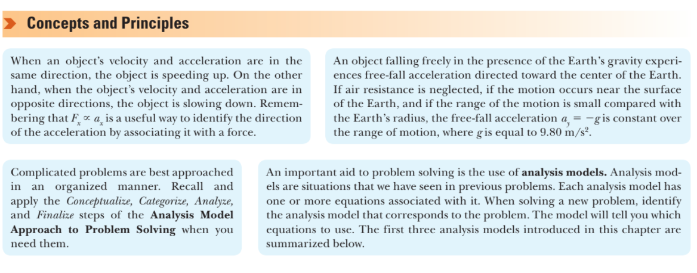

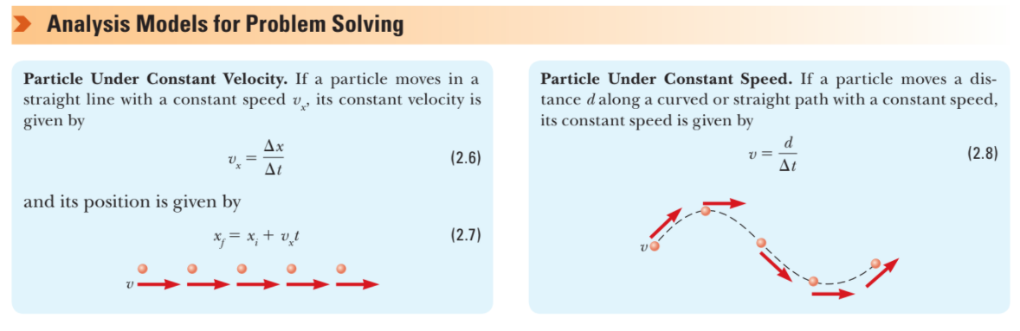

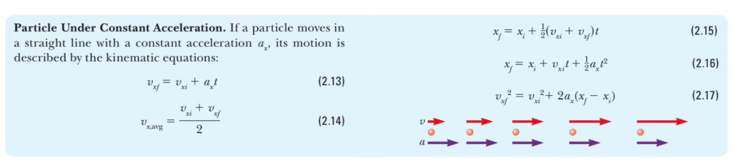

# 3. VECTORS

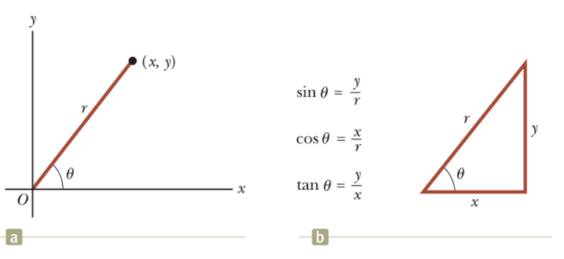

## 3.2 Vectors and Scalar Quantities

**Scalar quantity**: completely specified by a single value with an appropriate unit and has no direction (temperature, volume, mass, speed, time, time intervals)

**Vector quantity**: completely specified by a number with an appropriate unit (the magnitude of the vectors) plus a direction (wind velocity, displacement)

## 3.3 Basic Vector Arithmetic

Two vectors are equal if they have same magnitude and if the point in the same direction

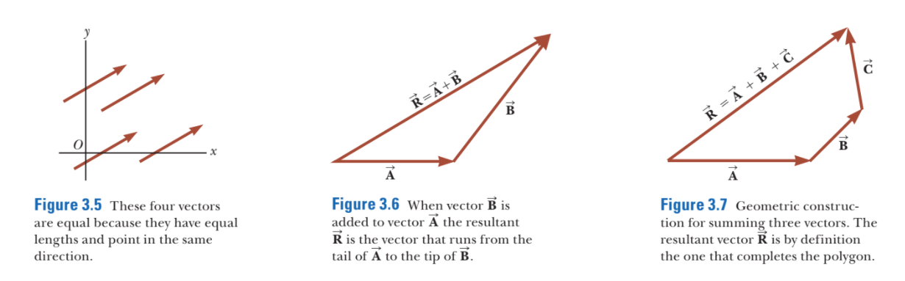

## 3.4 Components of a Vector and Unit Vectors

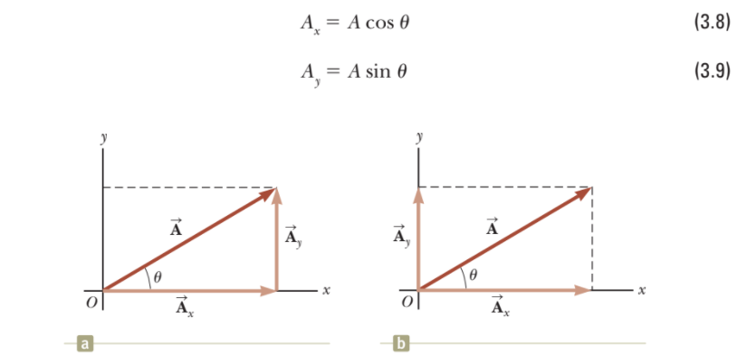

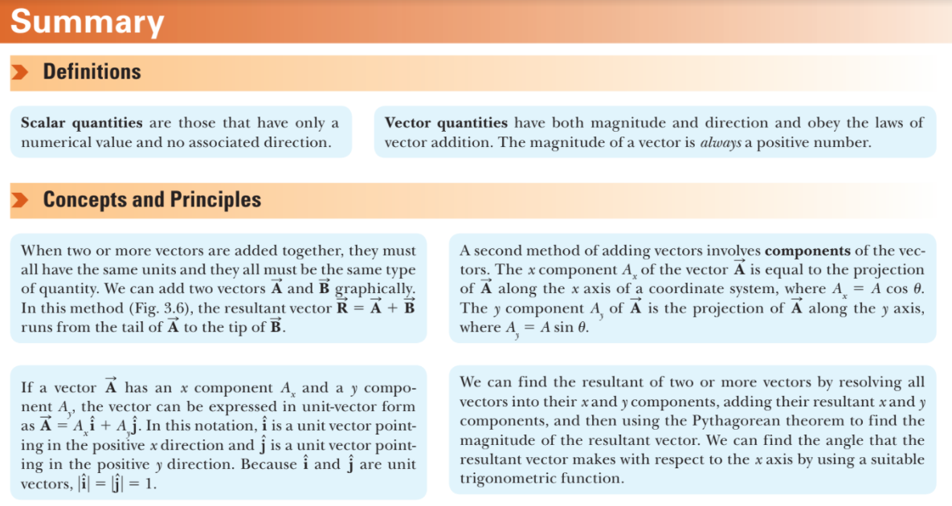

# 4. MOTION IN TWO DIMENSIONS

**Average velocity**: during a time Δt as the displacement of the particle divided by the time interval

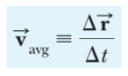

Multiplying or dividing a vector quantity by a positive scalar quantity such as Δt changes only the magnitude of the vector, not its direction

## 4.3 Projectile Motion

The path of a projectile (which is called trajectory) is always a parabola

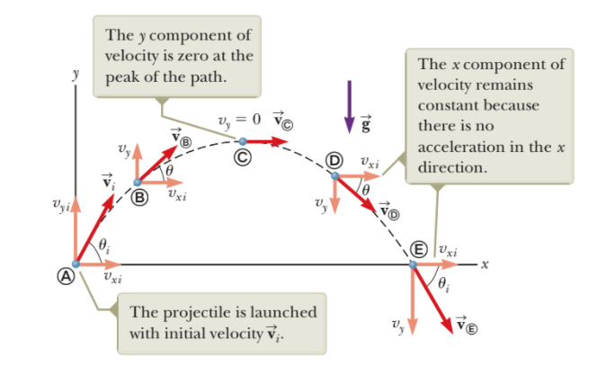

## 4.4 Analysis Model: Particle in Uniform Circular Motion

Uniform circular motion: if it is a circular motion with constant speed v

Even if an object moves at a constant speed in a circular path, it *still has an acceleration*, the direction of the velocity is always changing

**Centripetal acceleration for a particle in uniform circular motion**:

ac = v2 / r

**Period T**: time interval required for one complete revolution of the particle

T = 2πr / v

Measure of the number of seconds for one revolution of the particle around the circle. The inverse of the period is the **rotation rate** and is measured in revolutions per second

**Angular speed**

ω = 2π/T

v = rω

**Centripetal acceleration**:

ac = r ω

## 4.5 Tangential and Radial Acceleration

Tangential acceleration component causes a change in the speed v of the particle. This component is parallel to the instantaneous velocity, and its magnitude is given by

The radial acceleration component arises from a change in direction of the velocity vector and is given by

ar = -ac = - v2 / r

r: radius of curvature of the path at the point in question

